Request for the

SACRAMENT OF FIRST RECONCILATION

SACRAMENT OF FIRST EUCHARIST

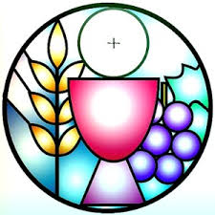

Name

Age

Father’s Name Mother’s Name

Address

Telephone Email

School or Program attending Grade

**Please Print clearly**

**CANDIDATES BAPTISMAL INFORMATION**

Candidate baptized in the Roman Catholic Church? Yes ☐ No ☐

If yes, please give name of the parish

Baptismal Certificates of Candidates who were not baptized at Our Lady of Lourdes Church, must accompany this form or submitted to the Parish Office at a later time. All Requests for Baptismal Certificates must be made to the parish of baptism.